**Section 1–6A: Absolute Value Equations**

Before we start, you should know that an absolute value quantity is nonnegative. Since opposites have the same absolute value, an absolute value equation can have **two** solutions.

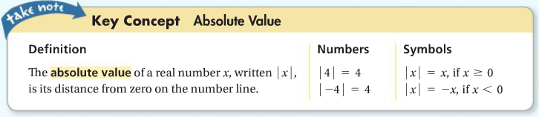

An absolute value equation has a variable within the absolute value sign. For example, $\left|x\right|=5$. Here, the value of $x$ can be $5$ or $-5$ since $\left|5\right|$ and $\left|-5\right|$ both equal 5.

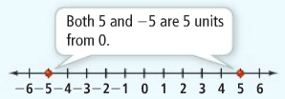

**Example 1: Solving an Absolute Value Equation**

What is the solution of $\left|2x-1\right|=5$? Graph the solution.

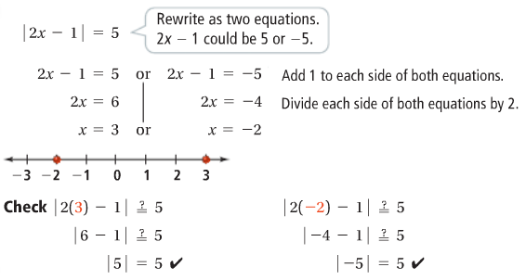

**Example 2: Solving a Multi-Step Absolute Value Equation**

What is the solution of $3\left|x+2\right|-1=8$? Graph the solution.

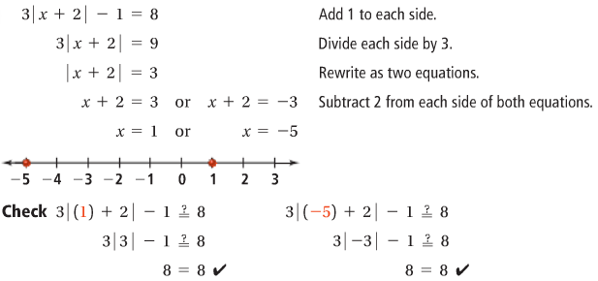

Distance from 0 on the number line cannot be negative. Therefore, some absolute value equations, such as $\left|x\right|=-5$, have no solution. **It is important to check the possible solutions of an absolute value equation.** One or more of the possible solutions may be *extraneous*. An **extraneous solution** is a solution derived from an original equation that is ***not*** a solution of the original equation.

**Example 3: Checking for Extraneous Solutions**

What is the solution of $\left|3x+2\right|=4x+5$? Check for extraneous solutions.

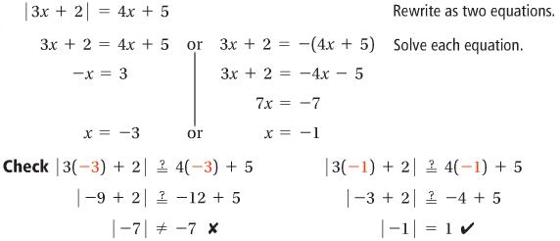

Since $x=-3$ does not satisfy the original equation, $-3$ is an extraneous solution. The only solution to the equation is $x=-1$.